
Worksheet 3
Student Name: Anindita Dhar UID:25MCA20259
Branch: MCA(General) Section/Group:25MCA-1-A
Semester: III Date of Performance: 22/08/2026
Subject Name: Internet Of Things Subject Code: 25CAH-708

Aim/Overview of the practical:
Interface an Arduino Uno with Ultrasonic Sensor to calculate the distance and print on a Serial monitor and on LCD. Follow the mentioned cases after the calculation of distance.
  - If the distance is > 250 cm green light is in ON condition.
  - If the distance is < 250 cm and the distance > 90 yellow light is in ON condition and the green light remains Off
  - If the distance is < 90 cm turn on the buzzer and lights will remain OFF.

Apparatus:
Hardware Requirements: Arduino Uno Board
Ultrasonic Sensor LCD (16*2)
Software requirements: TinkerCAD
MS Windows 10

Circuit Diagram(TinkerCad):
(Case 1) Coding:
#include <LiquidCrystal.h> LiquidCrystal lcd(12, 11, 5, 4, 3, 2);
// Ultrasonic sensor const int trigPin = 9; const int echoPin = 10;

// Green LED
const int greenLED = 6; void setup(){
pinMode(trigPin, OUTPUT); pinMode(echoPin, INPUT); pinMode(greenLED, OUTPUT);

Serial.begin(9600); lcd.begin(16, 2);
lcd.print("Distance:");
}

void loop()
{
digitalWrite(trigPin, LOW); delayMicroseconds(2); digitalWrite(trigPin, HIGH); delayMicroseconds(10); digitalWrite(trigPin, LOW);

long duration = pulseIn(echoPin, HIGH); float distance = duration * 0.0343 / 2; Serial.print("Distance: "); Serial.print(distance);
Serial.println(" cm");

lcd.setCursor(0, 0); lcd.print("Distance: "); lcd.setCursor(0, 1); lcd.print(distance); lcd.print(" cm ");

if (distance > 250){ digitalWrite(greenLED, HIGH); Serial.println("GREEN LED ON");
}
else{
digitalWrite(greenLED, LOW);
}
delay(500);
}

OUTPUT:
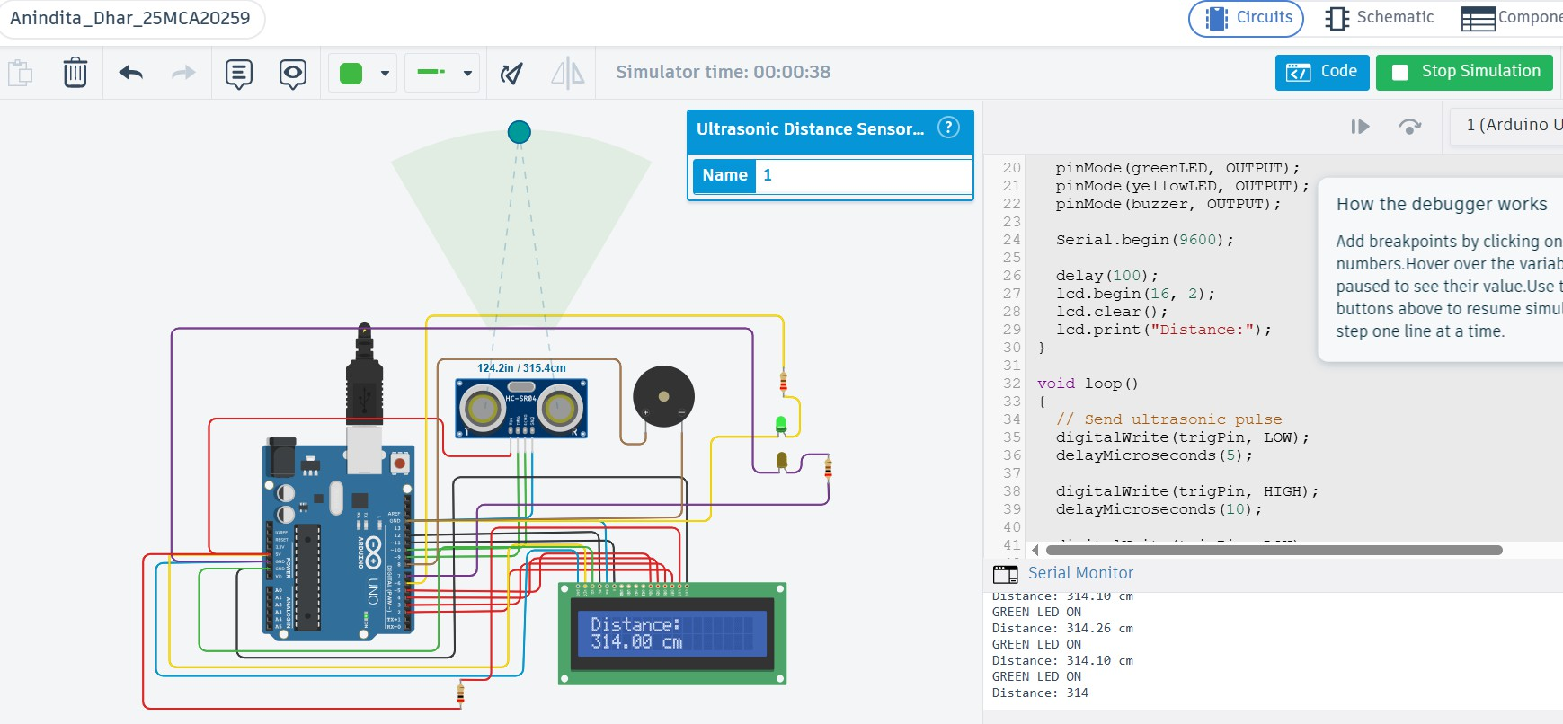

(Case 2) Coding:
#include <LiquidCrystal.h> LiquidCrystal lcd(12, 11, 5, 4, 3, 2);
// Ultrasonic sensor const int trigPin = 9; const int echoPin = 10;
// Yellow LED
const int yellowLED = 7; void setup()
{
pinMode(trigPin, OUTPUT); pinMode(echoPin, INPUT); pinMode(yellowLED, OUTPUT); Serial.begin(9600);
lcd.begin(16, 2);
lcd.print("Distance:");
}

void loop()
{
// Send ultrasonic pulse digitalWrite(trigPin, LOW); delayMicroseconds(2); digitalWrite(trigPin, HIGH); delayMicroseconds(10); digitalWrite(trigPin, LOW);

// Measure echo time
long duration = pulseIn(echoPin, HIGH);

// Calculate distance in cm
float distance = duration * 0.0343 / 2;

// Print on Serial Monitor Serial.print("Distance: "); Serial.print(distance); Serial.println(" cm");

// Print on LCD lcd.setCursor(0, 0); lcd.print("Distance: "); lcd.setCursor(0, 1); lcd.print(distance); lcd.print(" cm ");

if (distance < 250 && distance > 90)
{
digitalWrite(yellowLED, HIGH); Serial.println("YELLOW LED ON");
}
else
{
digitalWrite(yellowLED, LOW);
}
delay(500);
}

OUTPUT:
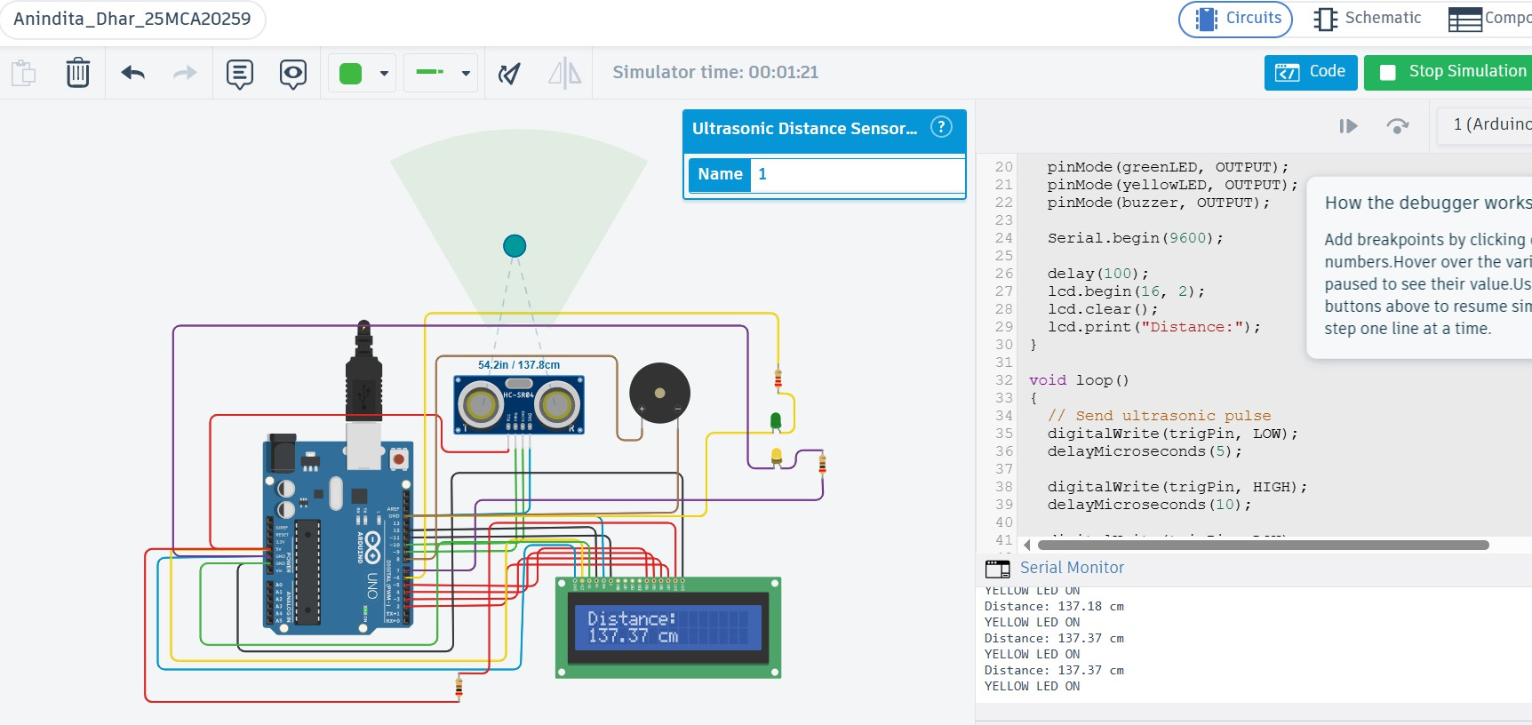

(Case 3) Coding:
#include <LiquidCrystal.h> LiquidCrystal lcd(12, 11, 5, 4, 3, 2);
// Ultrasonic sensor const int trigPin = 9; const int echoPin = 10;
// Buzzer
const int buzzer = 8;
void setup()
{
pinMode(trigPin, OUTPUT); pinMode(echoPin, INPUT); pinMode(buzzer, OUTPUT); Serial.begin(9600); lcd.begin(16, 2);

lcd.print("Distance:");
}

void loop()
{
digitalWrite(trigPin, LOW); delayMicroseconds(2); digitalWrite(trigPin, HIGH); delayMicroseconds(10); digitalWrite(trigPin, LOW);

long duration = pulseIn(echoPin, HIGH); float distance = duration * 0.0343 / 2; Serial.print("Distance: "); Serial.print(distance);
Serial.println(" cm");

lcd.setCursor(0, 0); lcd.print("Distance: "); lcd.setCursor(0, 1); lcd.print(distance); lcd.print(" cm ");
if (distance < 90)
{
digitalWrite(buzzer, HIGH); Serial.println("BUZZER ON");
}
else
{
digitalWrite(buzzer, LOW);
}
delay(500);
}

OUTPUT:
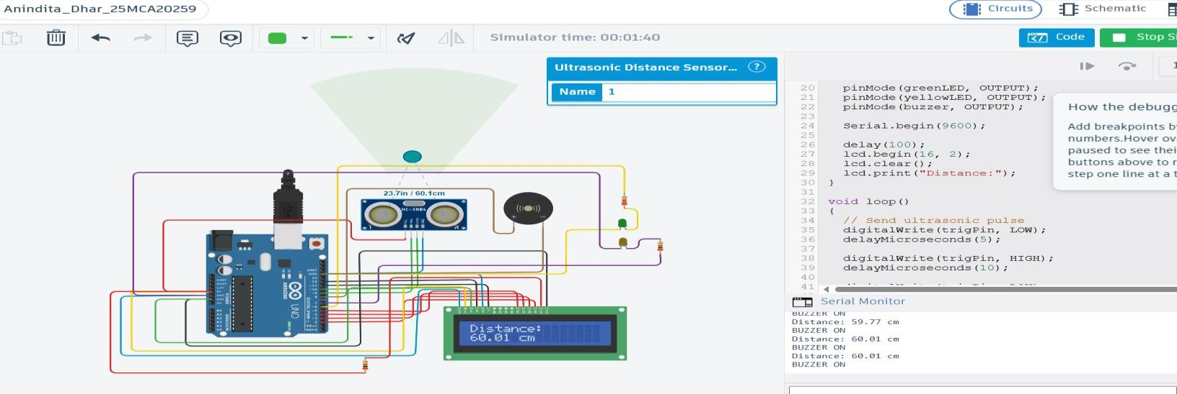

Learning outcomes (What I have learnt):
- Ultrasonic sensors and its properties.
- Interfacing of ultrasonic sensors with Arduino Uno and LCD.
- Connecting ultrasonic sensor ,Arduino Uno board and LCD in a circuit.

